**DIVERSITY, EQUITY & INCLUSION. HOW WILL IT LOOK LIKE IN 2023?**

**Global Annual Spending on DEI $ Billion**

|  |  |
| --- | --- |
| **Year** | **$ Billion** |
| 2022 | 9.4 |
| 2024 | 12. |
| 2026 | 15.7 |

**ERGs, the Largest Spending Area**

|  |  |
| --- | --- |
| **Segment** | **% Share** |
| Employee Resource Groups (ERGs) | 29.9 |
| External Partnerships | 22.6 |
| Training & Development | 20.3 |
| Recruitment | 14.6 |
| Other Segments | 12.6 |
| **Total** | **100.0** |

**Top Five Countries With the Most Inclusive Workspaces**

*(Plot these countries on the world map)*

1. Netherlands
2. Germany
3. Mexico
4. Spain
5. Canada

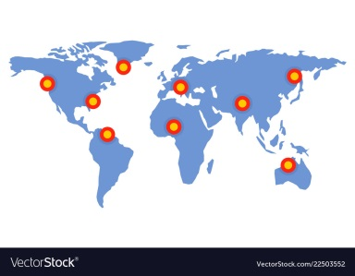

**DEI Failure is Fairly Common**

*(Represent the stats in the below sample figure)*

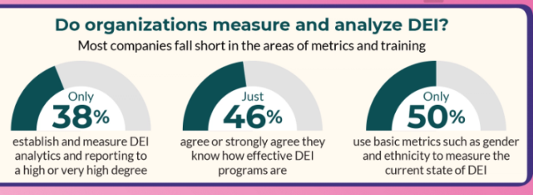

**38%** of companies establish and measure DEI analytics and reporting

**60%** companies acknowledge that they don’t know how effective their DEI strategies really are

**65%** companies do not use even basic metrics such as gender and ethnicity to measure the current state of DEI

**78%** feel they have not benefited from their company’s DEI programs

**58%** feel isolated in their workplace

**62%** have experienced discrimination at the workplace

**40%** of the time racism is the trigger for discrimination

**20%** of organizational leaders come from ethical/racial minority groups

**22%** of corporate leader represent women

**Strategies That Can Help**

*(Present the data in the below chart image)*

* Reevaluate the state of pay equity
* Offer training programs that instill cultural values
* Design & develop DEI metrics
* Recalibrate leadership initiatives to support women and ethnic/racial minorities
* Hire services of a DEI expert/professional
* Keep abreast of global regulations, policies and benefits
* Seek out opportunities to encourage diversity of thought

**Text Here**

**01**

This slide is 100% editable. Adapt it to your needs and capture your audience's attention.

**Text Here**

**02**

This slide is 100% editable. Adapt it to your needs and capture your audience's attention.

**Text Here**

**03**

This slide is 100% editable. Adapt it to your needs and capture your audience's attention.